LAB - 1
CSL 203

Karthik Krishnan
Roll No: 45
S3 CSE B
26-07-2024
Friday
Experiment No: 1
String Palindrome or Not
- Write a Java program that checks whether a given string is a palindrome or not. Ex: MALAYALAM is palindrome

Expected Output:
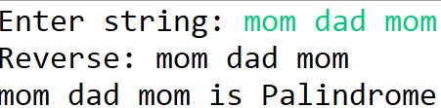
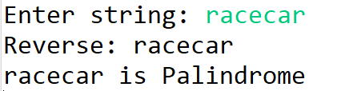

AIM
Write a Java Program to check whether a given string is Palindrome or not.

ALGORITHM
STEP 1: START
STEP 2: Read a String as input from the user and store in str
STEP 3: Initialize i,len
STEP 4: Find the length of string and store it in variable len
STEP 5: Initialize rev as empty string " ".
STEP 6: For i = len-1 to 0, repeat STEP 7.
STEP 7: Append str.charAt(i) to rev
STEP 8: If str equals rev, then print “Palindrome”
STEP 9: Else, print “Not Palindrome”
STEP 10: STOP

Program Code

package oopj24csb45;
import java.util.*;

public class Palindrome {
public static void main(String[] args) {
Scanner sc= new Scanner(System.in);
System.out.println("Enter a String: ");
String str=sc.nextLine();
int len=str.length();
String rev = " ";

for(int i=len-1; i>=0; i--)
{
rev = rev + str.charAt(i);
}
if(str.equals(rev))
{
System.out.println("Palindrome");
}
else
{
System.out.println("Not Palindrome");
}

}

}
Experiment No: 2
Frequency of a Character in a String
- Write a Java Program to find the frequency of a given character in a string.

Expected Output:
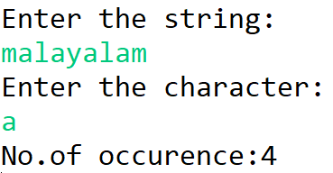

Experiment No: 3
Two Dimensional Array

Answer:

